the music of the spheres

p y t h a g o r a s

celestial bodies make music  
  
formed theories about the earth’s relationship to other planets – idea based in physical truths and metaphysical beliefs : the divine and poetic order of the universe could be known  
  
1:2 ratios produce an “octave” ~ e.g. string instruments : strings of different lengths (ratios) produce different tones  
  
sound is created through motion / vibration ~ sound waves travel to the middle and inner ear, where frequencies of vibration are transmitted then amplified

because objects produce sound when in motion, planets moving in orbit also produce a sound

geocentric diagram : eight steps from the earth to the “highest skies” (summum caelum) ~ between the Earth and the Moon is one full tone (tonus) ~ between the moon and Mercury is one half tone ~ between Venus and the Sun is one and a half tones; Pythagoras measures distance based on relative speed : faster moving planets were closer to the Earth, slower moving planets farther away ~ these ratios corresponded to tonal musical intervals in the Pythagorean scale ~ given that the planet’s distances were concordant with musical intervals, Pythagoras surmised that the resulting sound must be a harmony : *“music of the spheres”*

since the music of the spheres is continually sounding, humans have no real sense of silence or difference, and can therefore not distinguish it from our known idea of silence ~ Pythagoras introduces another level of understanding based on the audible and the inaudible ~ the mythic notion of panaurality or “all sound” is a revolutionary idea (ancient Greeks have mostly been associating with the visible, physical world until this point)

“there is geometry in the humming of the strings, there is music in the spacing of

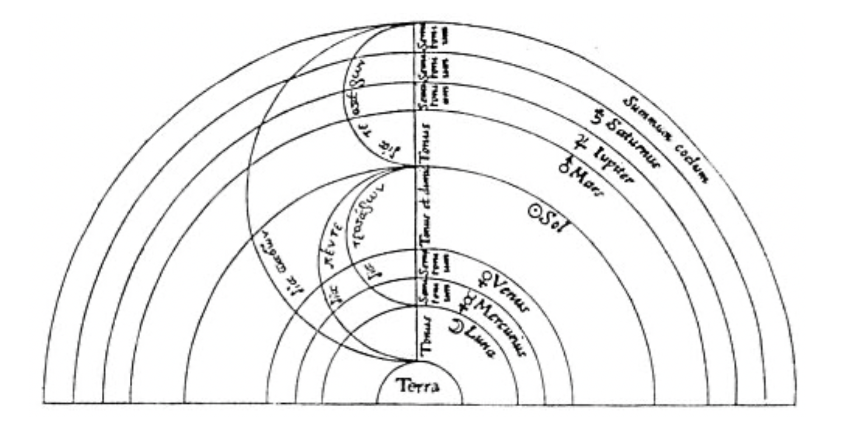

Johannes Kepler

17th century : Harmonices Mundi ~ working from a heliocentric, Copernican model of the universe ~ refining the harmonics of the universe resulting in his “Third Law” determining the elliptical (not circular) motion of planets

formulated the three Kepler’s laws ~ describing the fundamental principles of motion of the planetary system  
  
*“The heavenly motions are nothing but a continuous song for several voices (perceived by the intellect, not by the ear); a music which… progresses towards certain pre-designed, quasi six-voiced clausuras, and thereby sets landmarks in the immeasurable flow of time.”*

/

Arthur Koestler  
  
*“Saturn, for instance, when farthest away from the sun, in its aphelion, moves at the rate of 106 seconds arc per day; when closest to the sun, and its speed is at maximum, at 135 seconds arc per day. The ratio between the two extreme velocities is 106 to 135, which only differs by two seconds from 4:5- the major third. With similar, very small deviations (which were all per­fectly explained away at the end), the ratio of Jupiter's slowest to its fastest motion is a minor third, Mars' the quint, and so forth. The extreme values yield in fact the intervals of the complete scale. But not enough: if we start with the outermost planet, Saturn, in the aphelion, the scale will be in the major key; if we start with Saturn in the perihelion, it will be in the minor key. Lastly, if several planets are simultaneously at the extreme points of their respective orbits, the result is a motet where Saturn and Jupiter represent the bass, Mars the tenor, Earth and Venus the contralto, Mercury the soprano. On some occa­sions, all six can be heard together.”*

Brian Greene ~ s t r i n g t h e o r y

superstring theory ~ the idea that minuscule strands of energy vibrating in 11 dimensions create every particles and force in the universe

tries to answer the question what the fundamental constituents of the universe are ~ vibrating filaments of energy are at the core of particles and all elements of the universe ~ different frequencies of vibration create different particles; different particles create the richness of matter in the universe

mathematics : superstring theory only works in 10 dimensions of space and 1 dimension of time ~ dimensions have rich internal geometry; dimensions fold in on themselves and intertwine  
  
strings are affected by the vibrational patterns and geometry by which they are moving  
  
the tone at which a string vibrates determines its physical form  
  
Many physicists, including Stephen Hawking believe that string theory could be “the theory of everything”

the visual ~ the aural  
  
*“There is geometry in the humming of the strings, there is music in the spacing of the spheres”* Pythagoras

harmony of the spheres

*“spiritual hearing”*

as soon as the “clairvoyant” ascends from the soul-land into the spirit-land, the perceived archetypes also become sounding ~ sounding as a purely spiritual process, it must be imagined without all thought of a physical sound ~ a sea of tones through which the entities of the spiritual world express themselves

what the mind perceives in the physical world as a law, as an idea, presets itself to the “spiritual ear” as a spiritual-musical

unlike the sensually audible sounds, the sphere sounds do not live in the air as a carrier medium, but in the much finer Akasha materials in which “thought can express itself directly” and which is also the carrier of the world memory

resounding space (space resounds in a the higher, finer substance than air, the Akasha substance) ~ becoming able to hear the music of the spheres which floods the space of the world, the heavenly world ~ d e v a c h a n

harmony of the spheres and the etheric body ~   
  
the etheric body contains the finer substantialities of the human being, in the etheric body also lives that which belongs to the sun, that which was active as the harmony of the spheres: *“in the etheric body live high gods, and just such as are related to the sun-gods”*